桃育108年度英國牛津遊學團生活日誌優良作品分享
第五名佳作
桃育高二51班 黃芷翎(Emma)

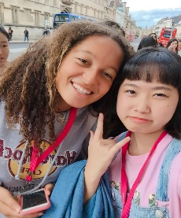
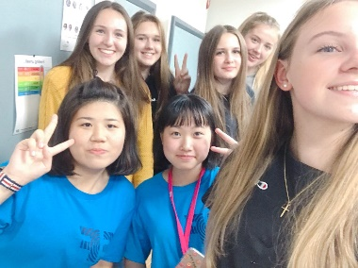
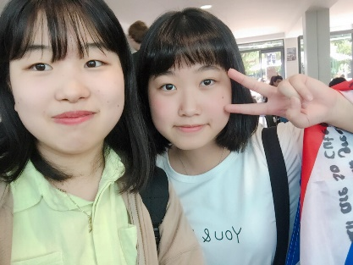
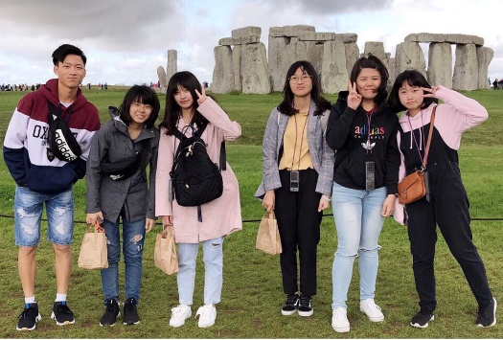
In the UK of 18 days，I made many friends and learned many new things in EF. The first day evening in EF，Lily and I were playing Billiard ball with many foreigners. And then we knew each other，I was so happy that I met many beautiful foreigner on the first day. When EF staff took us on a guided tour to Oxford, I met a girl from Spain. She was a very nice person. On weekend, I spent 45 pounds visiting Stonehenge. I thought Stonehenge had a lot of fun, but I didn't think because it was just a bunch of stones. We met Ruby there, and then she saw us as usual and said we were cute and took pictures for us. In England, we, six people, always went out together. Whether we went downtown for shopping or had meals in the cafeteria at noon or in the evening, the six of us were basically together. I was very happy to meet them in England. In EF, I most often met were Japanese people, maybe our English were all not very good, haha…
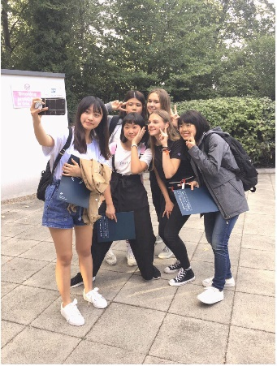
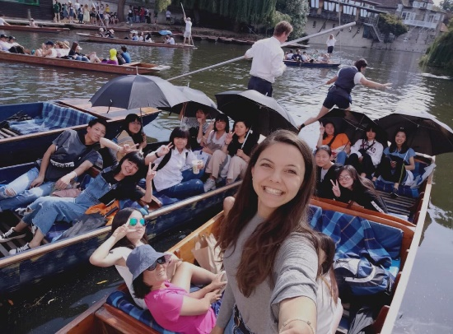
I had a very close Japanese friend, whose name was TAE, and she was a very lovely girl, sometimes we spoke English to each other but did not know each other's meaning. We would use google translation to understand each other, so I felt it was very funny. Besides, I taught her Chinese, and she taught me Japanese. After leaving EF, we went to Cambridge University. We were sitting in a small boat, someone rowing a boat, introducing us to the beauty of the surrounding sour area, the boat and umbrellas for us to shade the sun! Since I graduated from EF, I've been thinking about my life in Oxford, my friends, and a lot of memorable things. If there's a chance in the future, I hope I can do it again, it's really a valuable experience for me! New I miss
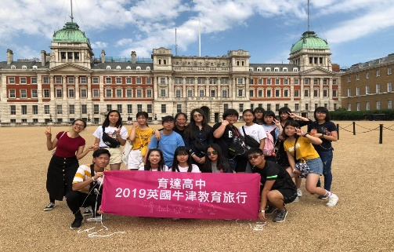
a beautiful view there.

