桃育108年度英國牛津遊學團生活日誌前三名作品分享
第三名
桃育高二51班梁妤暄

Study tour in England
During the summer vacation, I went to the United Kingdom and started my study tour for two weeks.
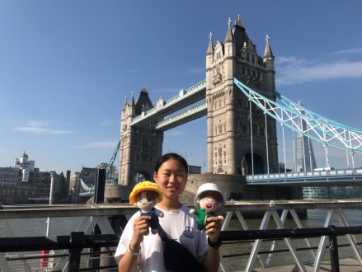
The first stop was EF Oxford International School, we were all looking forward to the trip on the following few days.
I went to the lots of place and the scenery there really caught my eyes. I went to plenty of beautiful sites, such as Windsor Castle, Bridge of Sighs, London Eye, Tower Bridge, Bristol and Bath, etc.I took lots of picture so that I could remember the beautiful construction and everything I saw in England.
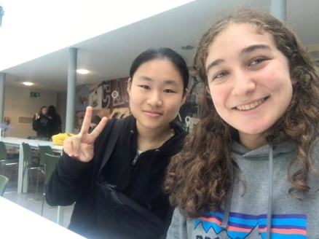
The first person that I met in the school was my roommate, she came from Czech Republic and she was the same age as me. She told me lots of things about the school and we went to the city center together. We had a wonderful day! As usual, I went to the school and took my courses. At first, I was nervous in class but I overcame it after a girl talked to me. She was really kind. When I got lost in the city center, she said she would try to find me. This action made me feel touched. She came from Spain and I would not forget her kindness. She really helped me a lot when I needed any help.
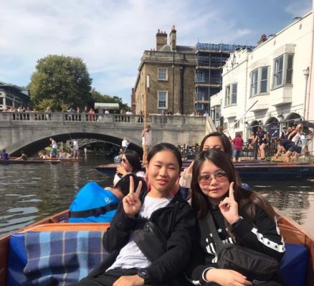
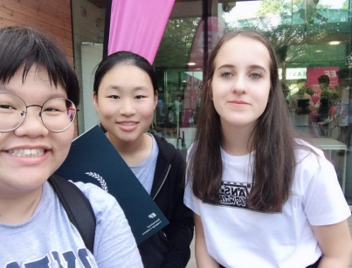
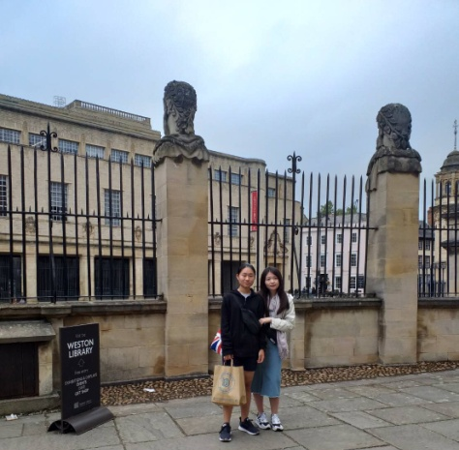
Everything in the United Kingdom are unforgettable. Everything in Oxford also impressed me deeply. I improved my English speaking ability a lot from a study tour in England. At the end of my report,I want to thank my parents and director of apply foreign language department. Thanks the director of apply foreign language department fight for a chance for us to go to England and thanks my parents who give me lots of courage to go aborad. I apperciate it a lot and with a lot of happiness in my memory.

