桃育108年度英國牛津遊學團生活日誌前三名作品分享
第二名
桃育高三51班 黃翊淳

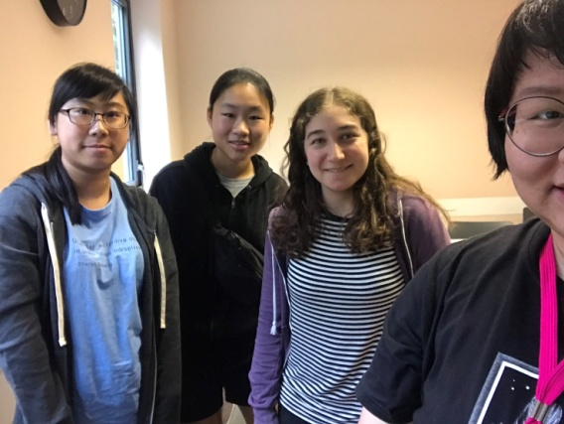
We felt tired when we arrived in the UK. On Tuesday, our classes began and the afternoon we had walking tour with EF. On the way to Westgate mall, I made many friends from different countries. After three days, we went to Windsor Castle, where I saw the history of royalty. The next morning, we came to Stonehenge which was magnificent. In the afternoon, we went to Bath, where we visited Bath Abby, and we saw a lot of beautiful stained glasses and a large place for paying.
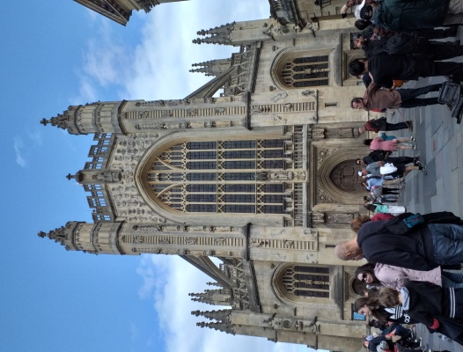
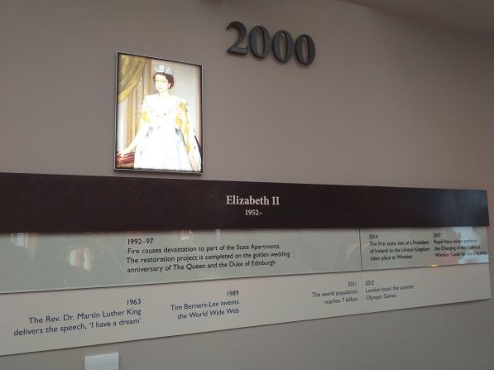
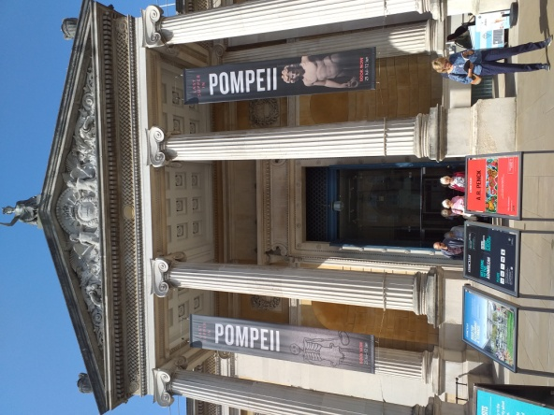
The second week, Charlotte and I visited Ashmolean Museum, the second largest museum in England. It exhibits money’s history, status of ancient Greeks, mummies and so forth. I saw Sun Yat-sen’s head on a banknote, but the banknote was provided by Hong Kong. When I watched it, I felt unbearable because Sun Yat-sen is the Father of Taiwan. I also saw a young mummy which was made up of some iron wires. It said the mummy was too young to represent in public so it had to scan and then imitated it. Next afternoon, my friends and I went to Museum Of Natural History that I saw a hive and thousands of hundreds of bees in the transparent box. I was suddenly shaking, and then my friends asked me”What happened?” I responded “Nothing! I was just shocked because there was a sound like bee’s flapping wings.” After they heard it, they laughed at me a lot. I felt embarrassed and my face turned red immediately. On evening, we went to enjoy musical which was The Lion King. The musical was so excellent, and its stage effect, stage equipment even lighting were so awesome and amazing.
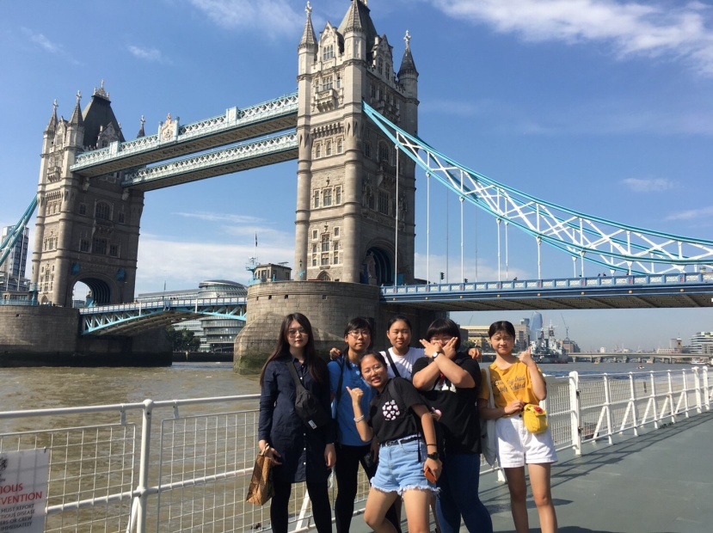
The last day in London, Judy, Vivian and I were lost. When we were ready to go back to our youth hostel, we needed to take subway back to hostel. However, we walked to the first subway station; it didn’t take any banknote so we had to go to the next subway station. Fortunately, we bought an oyster card and took subway back to our youth hostel safely and soundly. That day was a tiring day. To sum up, I feel this journey is very rewarding.

