桃育108年度英國牛津遊學團生活日誌前三名作品分享
第一名
桃育高三51班 吳昕珆
Study in Oxford
At first, I was nervous because it was my first time in Oxford, England. After a few days later I found that I liked this place very much because of the weather, the environment, and the buildings. My room was comfortable and the bed was soft. I liked to lie on my bed and chat with my roommates. My teacher was so friendly and always encouraged me to express my ideas. I learned a lot of things from her and I really enjoyed the class, too. I also made friends here who were from Poland, France, and Australia, etc. We went out to have lots of fun together, so I saw the beauty of this city and a different culture.
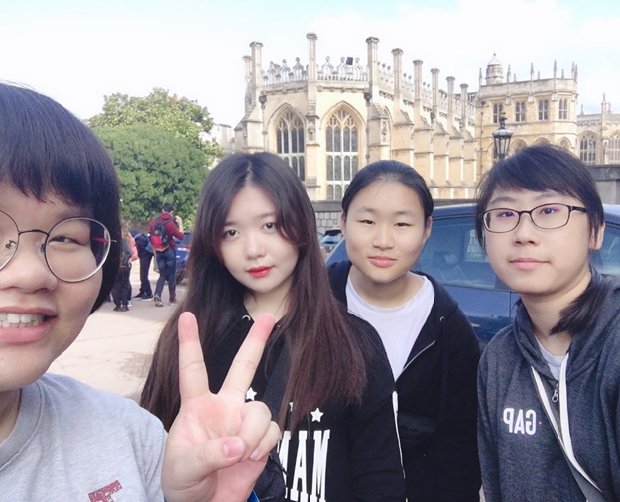
We arrived at Windsor Castle on the first weekend. It was beautiful and the shopping streets were also unique and amazing. On the second week, I went to Oxford University Museum of Nature History with my French friend. We had a great time watching dinosaurs’ fossils and ancient civilization. The next day I went to London and watched the musical show of The Lion King. I was very touched about the story, the characters, and their songs. 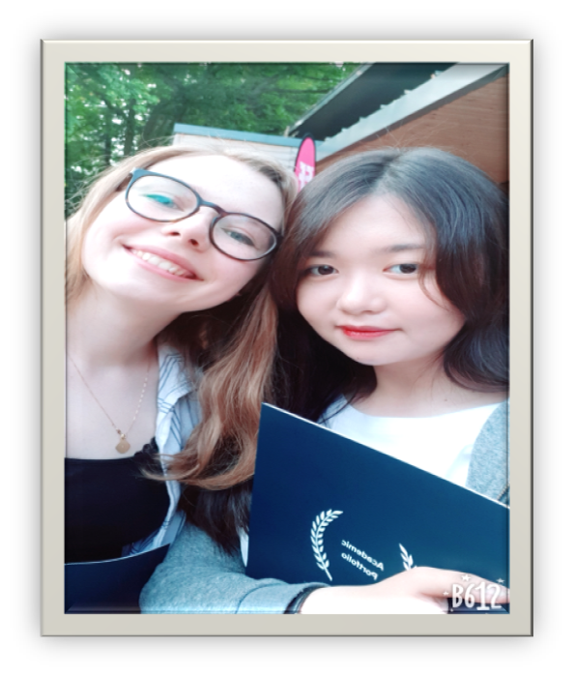 The last weekend I went to Cambridge and London, I really enjoyed punting in Cambridge because their buildings and weather were so great and magnificent. But it was a bit scary in London because my friends and I lost the way back to our hostel and our smartphone’s power was only 1% left. At that time I thought maybe we wouldn’t be able to go back to the hostel.
Fortunately, we finally found it so I cried at the same time. It was a pretty cool experience to remind me that I should bring portable charger with me all the time. Here I learned how to be brave and how to solve the problems independently by myself. Needless to say, I will always remember the happy time in England.
